Bell shaped distributions

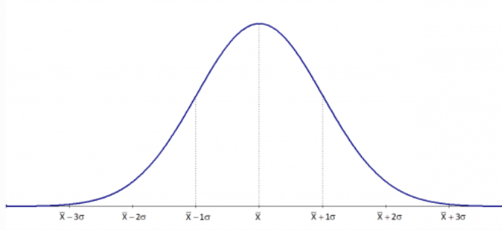

Less data🡨--------------------------most data---------------------------------🡪less data

Roughly symmetric

One special bell curve:

The normal distribution(or normal curve)



For perfect bell shaped distribution

Symmetric MEAN=MEDIAN

Normal distribution is determined by-🡪 the mean -🡪 the standard deviation(measure of spread)

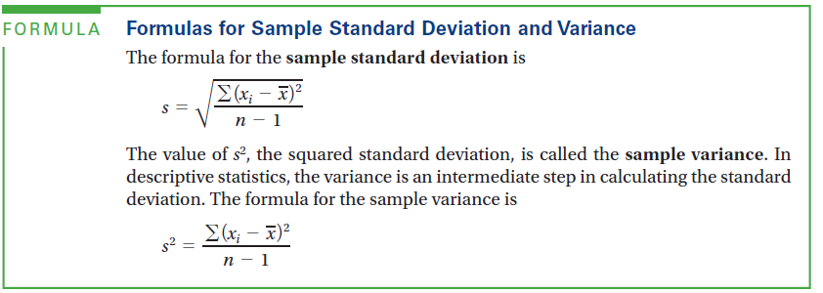

**(n-1)🡪 number of degrees of freedom**

**Capital Sigma🡪means add up**

**Roughly the “average” distance to mean**

**Ex2:**

59.72.77.86

1st: find mean

X=(59+72+77+86)/4=73.5

Next find deviations suqre them

|  |  |
| --- | --- |
|  | (Xi-x)2 |
| 59 | (59.73.5)2=210.25 |
| 72 | (72-73.5)2=2.25 |
| 77 | (77-73.5)2=12.25 |
| 86 | (86-73.5)2=156.25 |
|  | Total =381 |

The reason to square them if we don’t square , the values will cancel out each other when adds up.

S2= 381/(4-1)=127

S=11.3

For population

Mean: 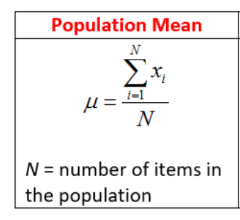

Standard deviation:

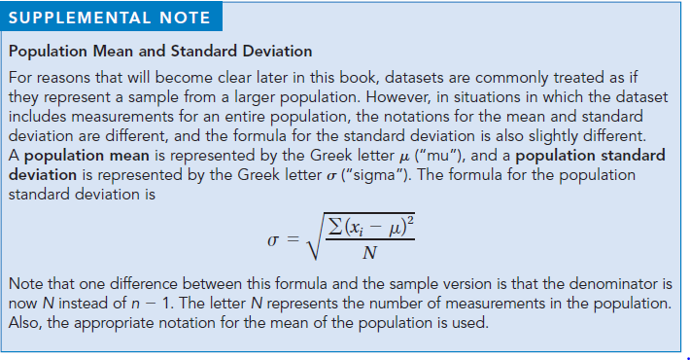

The Empirical Rule

For any bell-shaped curve:

About 68% of the data are between 1st. deviation below the mean and 1st deviation about the mean

About 95% of within 2nd deviation of the mean

About 99.7% within 3rd deviation of the mean

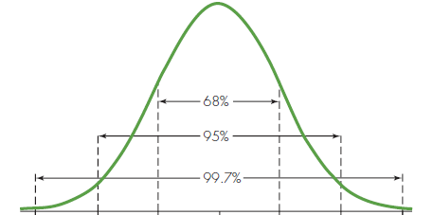

IF data set is large-ish(N is equal or greater than 200)

S is approx. Range/6

Standardized scores:

